**PROBLEM STATEMENT**

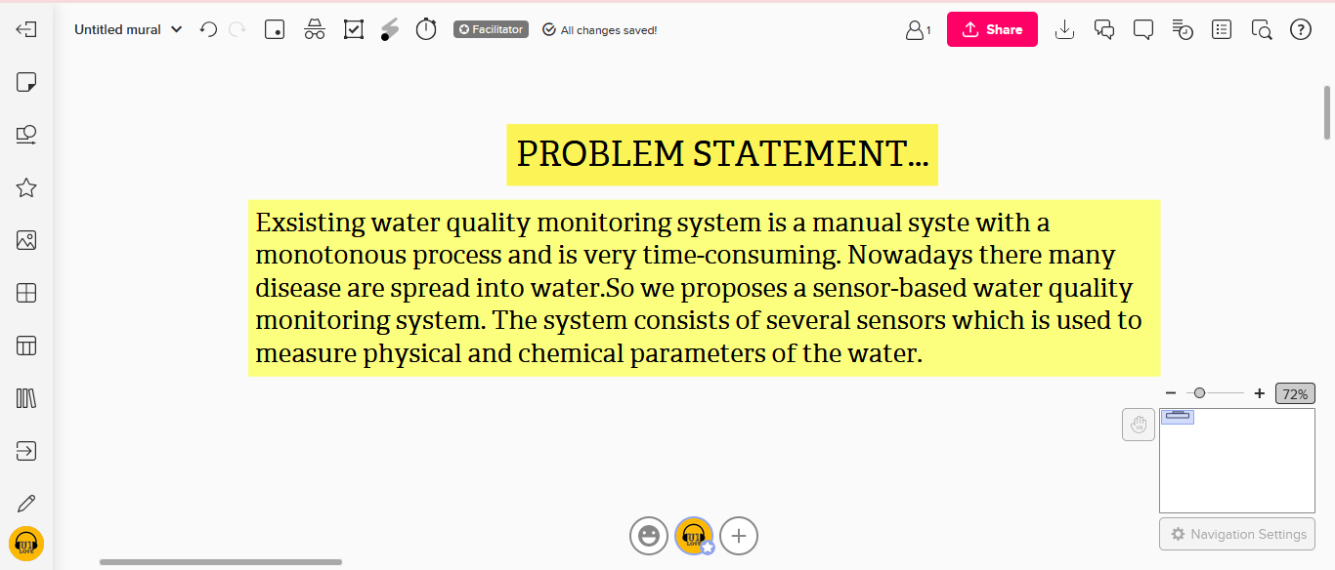

# SUBMITTED BY

# KANNAGI